

**SUBMISSION TO: SIR Asad Sajjad**

**SUBMITTED BY: AZNA IJAZ**

**ROLL NO: B-24684**

**DEPARTMENT: COMPUTER SCIENCE (SEM-4 A)**

**SUBJECT: Web System and Technologies**

**SUBMISSION DATE:08 -03-2021**

**Portfolio in HTML language:**

<head>

<title>

HOME PAGE

</title>

</head>

<center>

<center><img src="https://www.zahnarzthamburg-hohenfelde.de/wp-content/uploads/2013/04/female-user-icon-clip-art.jpg"></center>

<body bgcolor=" #ffe6e6">

<center><h1><b>AZNA IJAZ</b></h1></center>

<a href="file:///C:/Users/ok/Desktop/assignments/html/Home.html" target="_blank" title=" HOME " </font><h6>HOME</h6>

<a href="file:///C:/Users/ok/Desktop/assignments/html/aEducation.html" target="_blank" title= "EDUCATION"><p style ="color: #F2A365;font-size : 50 px"><h6>EDUCATION</h6></p></a>

<a href="file:///C:/Users/ok/Desktop/assignments/html/Skills%20Highlights.html" target="_blank" title="SKILLS"><h6>SKILLS</h6></a>

<a href="file:///C:/Users/ok/Desktop/assignments/html/Hobbies.html" target="_blank" title="HOBBIES"><h6>HOBBIES</h6></a>

<a href="file:///C:/Users/ok/Desktop/assignments/html/Contact%20us.html" target="_blank"<font = "title="CONTACT US"></font><h6>CONTACT US</h6></a>&nbsp;&nbsp; &nbsp;&nbsp;</center>

</center>

<hr>

</hr> <footer><center><p style="background-color:#660000; color:yellow;"><b>@CopyRights by Azna Ijaz 2021 </b> </center></footer></body>

</hr>

</html>

**SCREENSHOTS:**

**Main Page**

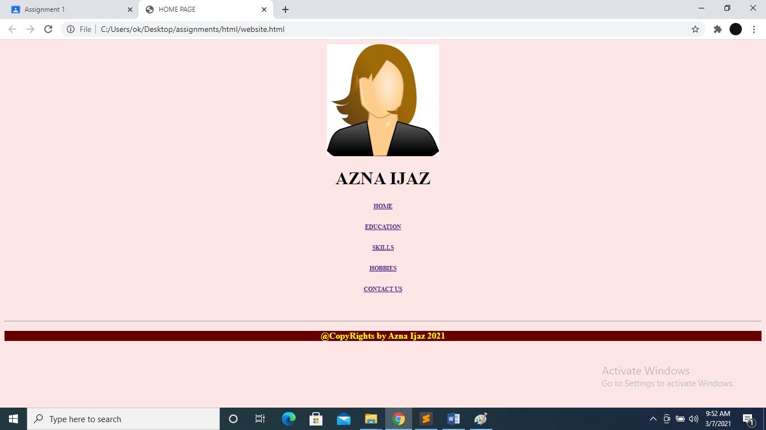

**HOME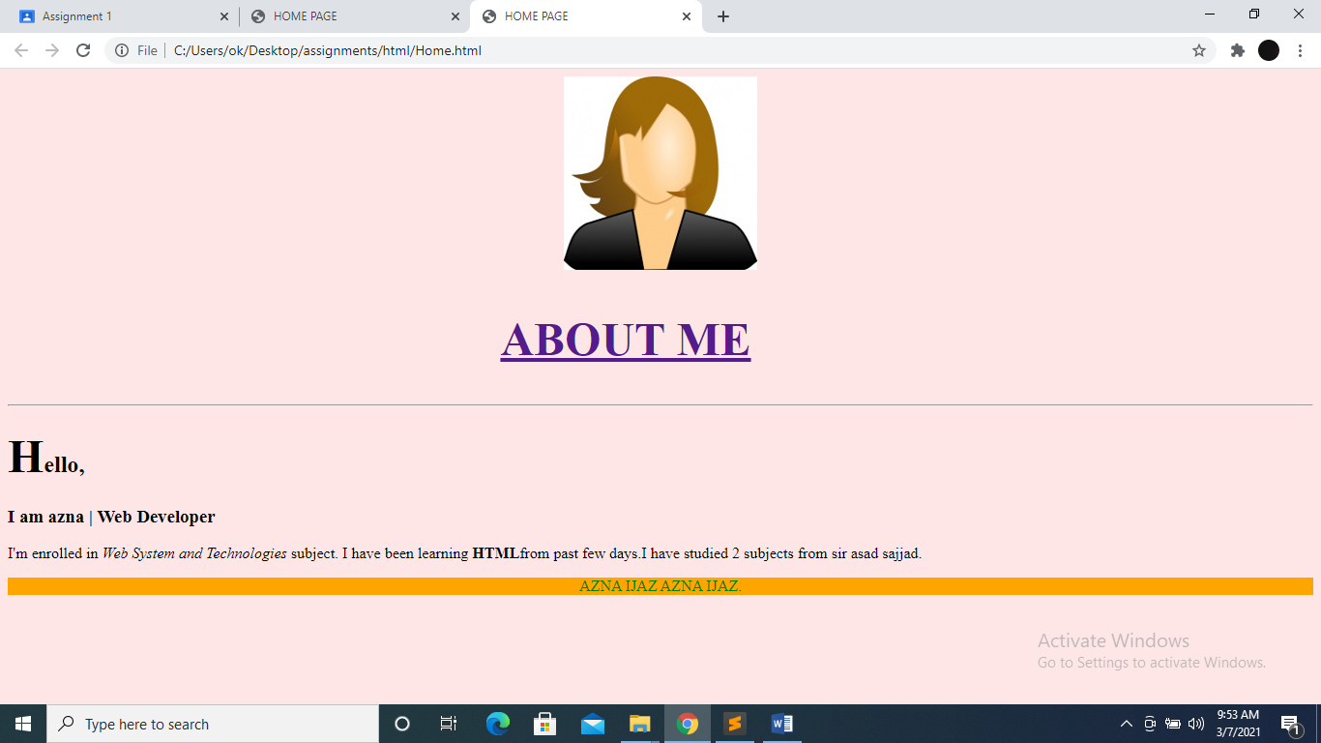Education:**

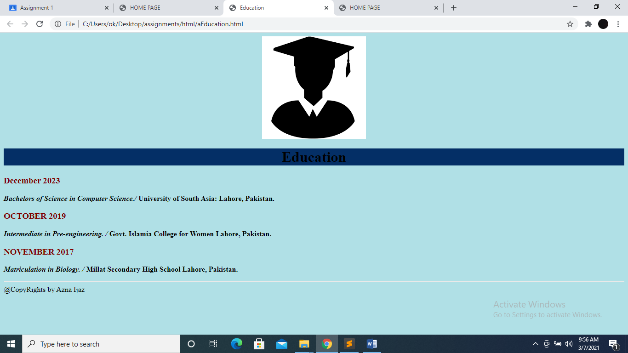

**Skills:**

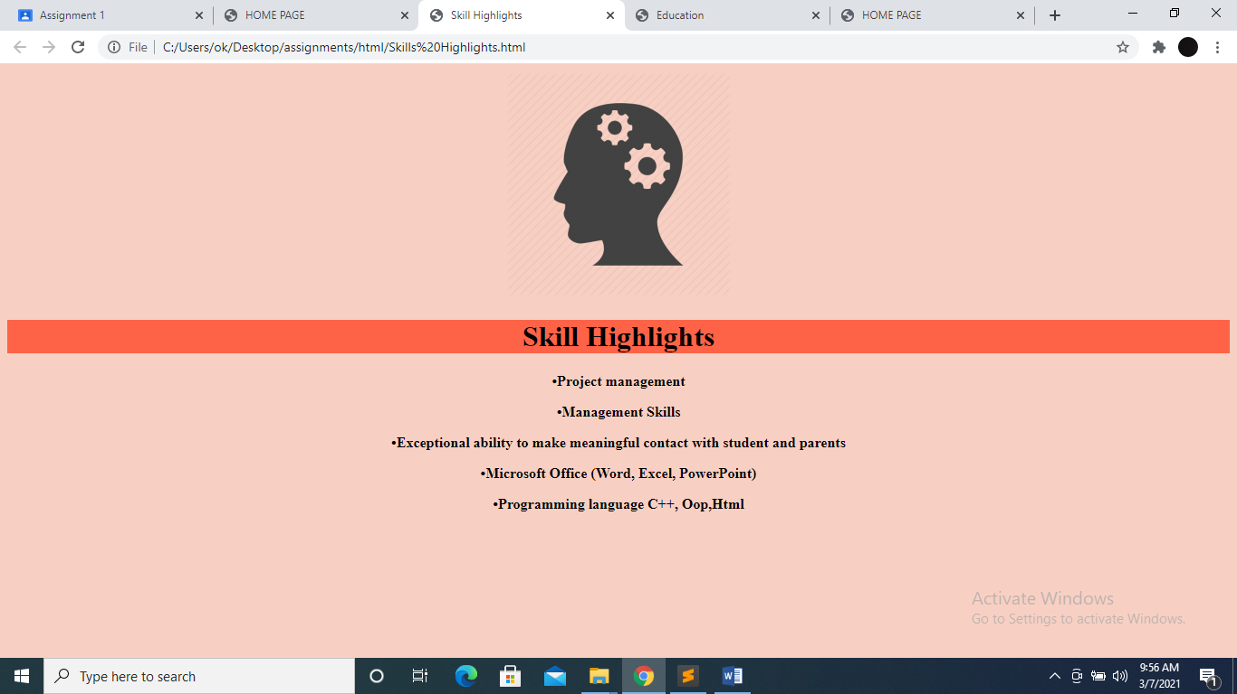

**ACHIVEMENTS & HOBBIES:**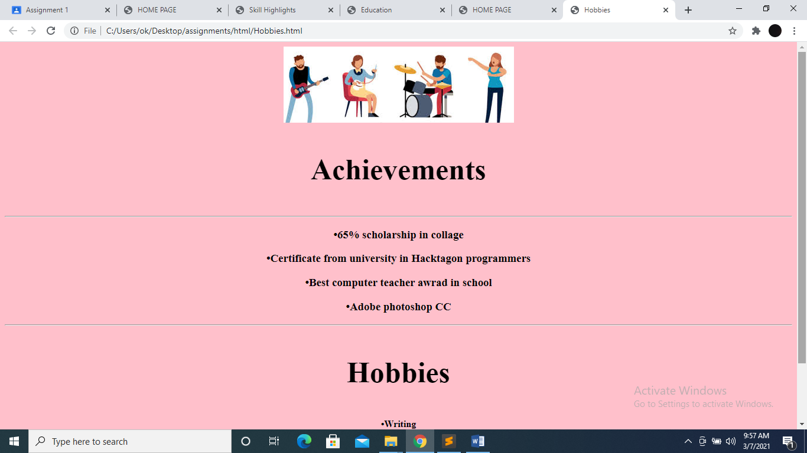

**Contact:**

